Daniel DeCarlo

Box # 107

Cairn University School of Business

CIS122 Essentials of Networking

Project #

Project objective:

* Setting up a media server to have connected networks and having other computers see what is being projected on a main screen.
* Installing wire shark and tcdump command to help assist with the media server project.

Equipment used:

|  |  |  |  |  |  |  |  |  |
| --- | --- | --- | --- | --- | --- | --- | --- | --- |
| Equipment Description | | Vendor | | Vendor Item # | | Retail price | | Actual price (if known) |
| VNC Software | | REALVNC https://www.realvnc.com/en/connect/download/viewer/ | | SHA-256: 1f7ea51b3061183fb3b8a49dddc26014439d856eb35417aed0f50332dc868e7c | | FREE | |  |
| Raspberry Pi (2x) | | Amazon (Canakit)  <https://www.amazon.com/CanaKit-Raspberry-Clear-Power-Supply/dp/B01C6EQNNK/ref=sr_1_2?ie=UTF8&qid=1548968817&sr=8-2&keywords=rasberi+pi> | | **MODEL #:** LYSB01C6EQNNK-ELECTRNCS  **ASIN**:  B01C6EQNNK | | $49.99  X2  Total:  $99.98 | | |

Detailed list of software and operating platforms used, including version numbers and licensing requirements:

VNC VIEWER (EXE x86/x64) Version #: SHA-256: 1f7ea51b3061183fb3b8a49dddc26014439d856eb35417aed0f50332dc868e7c

**Licensing:**

<https://www.realvnc.com/en/legal/#eulas>

Network diagram:

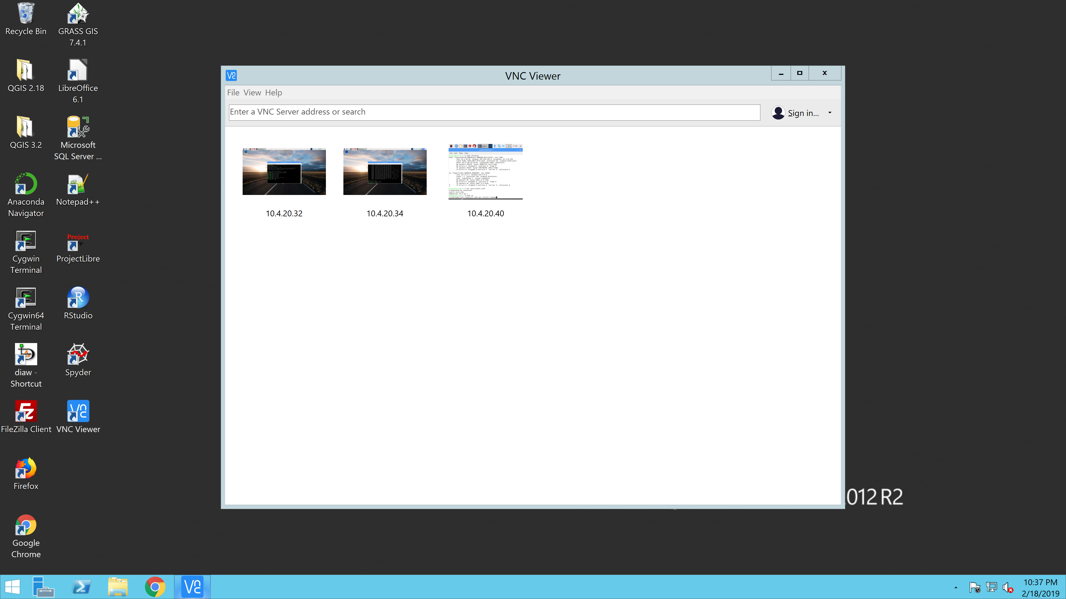

Enter IP address

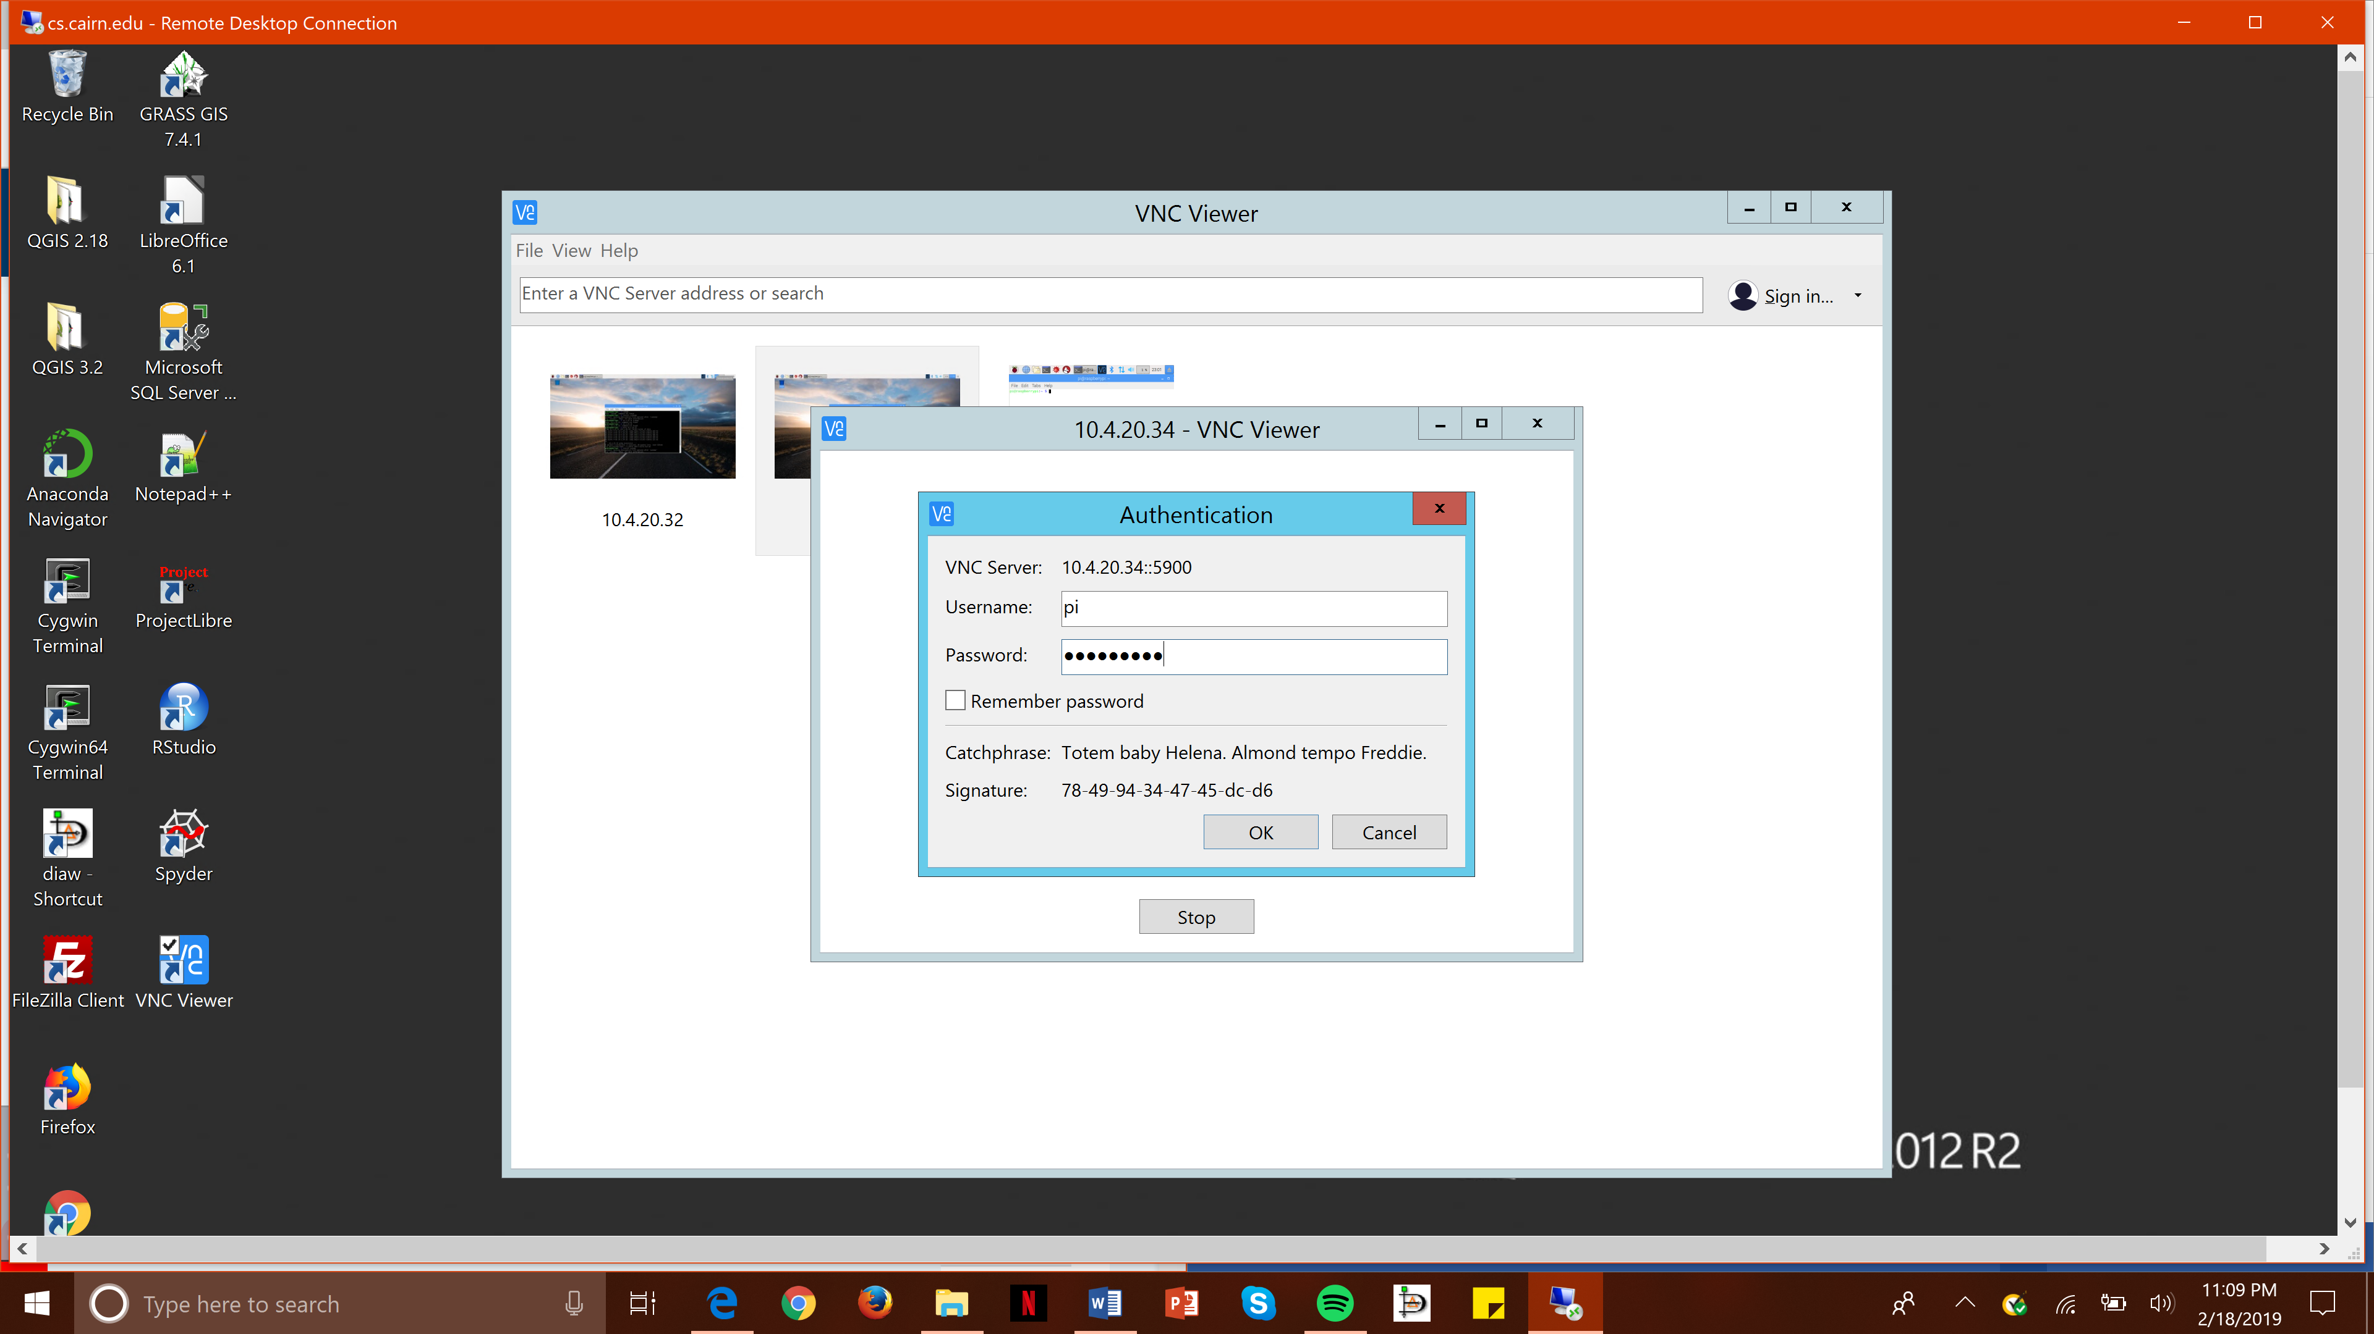

Enter Password

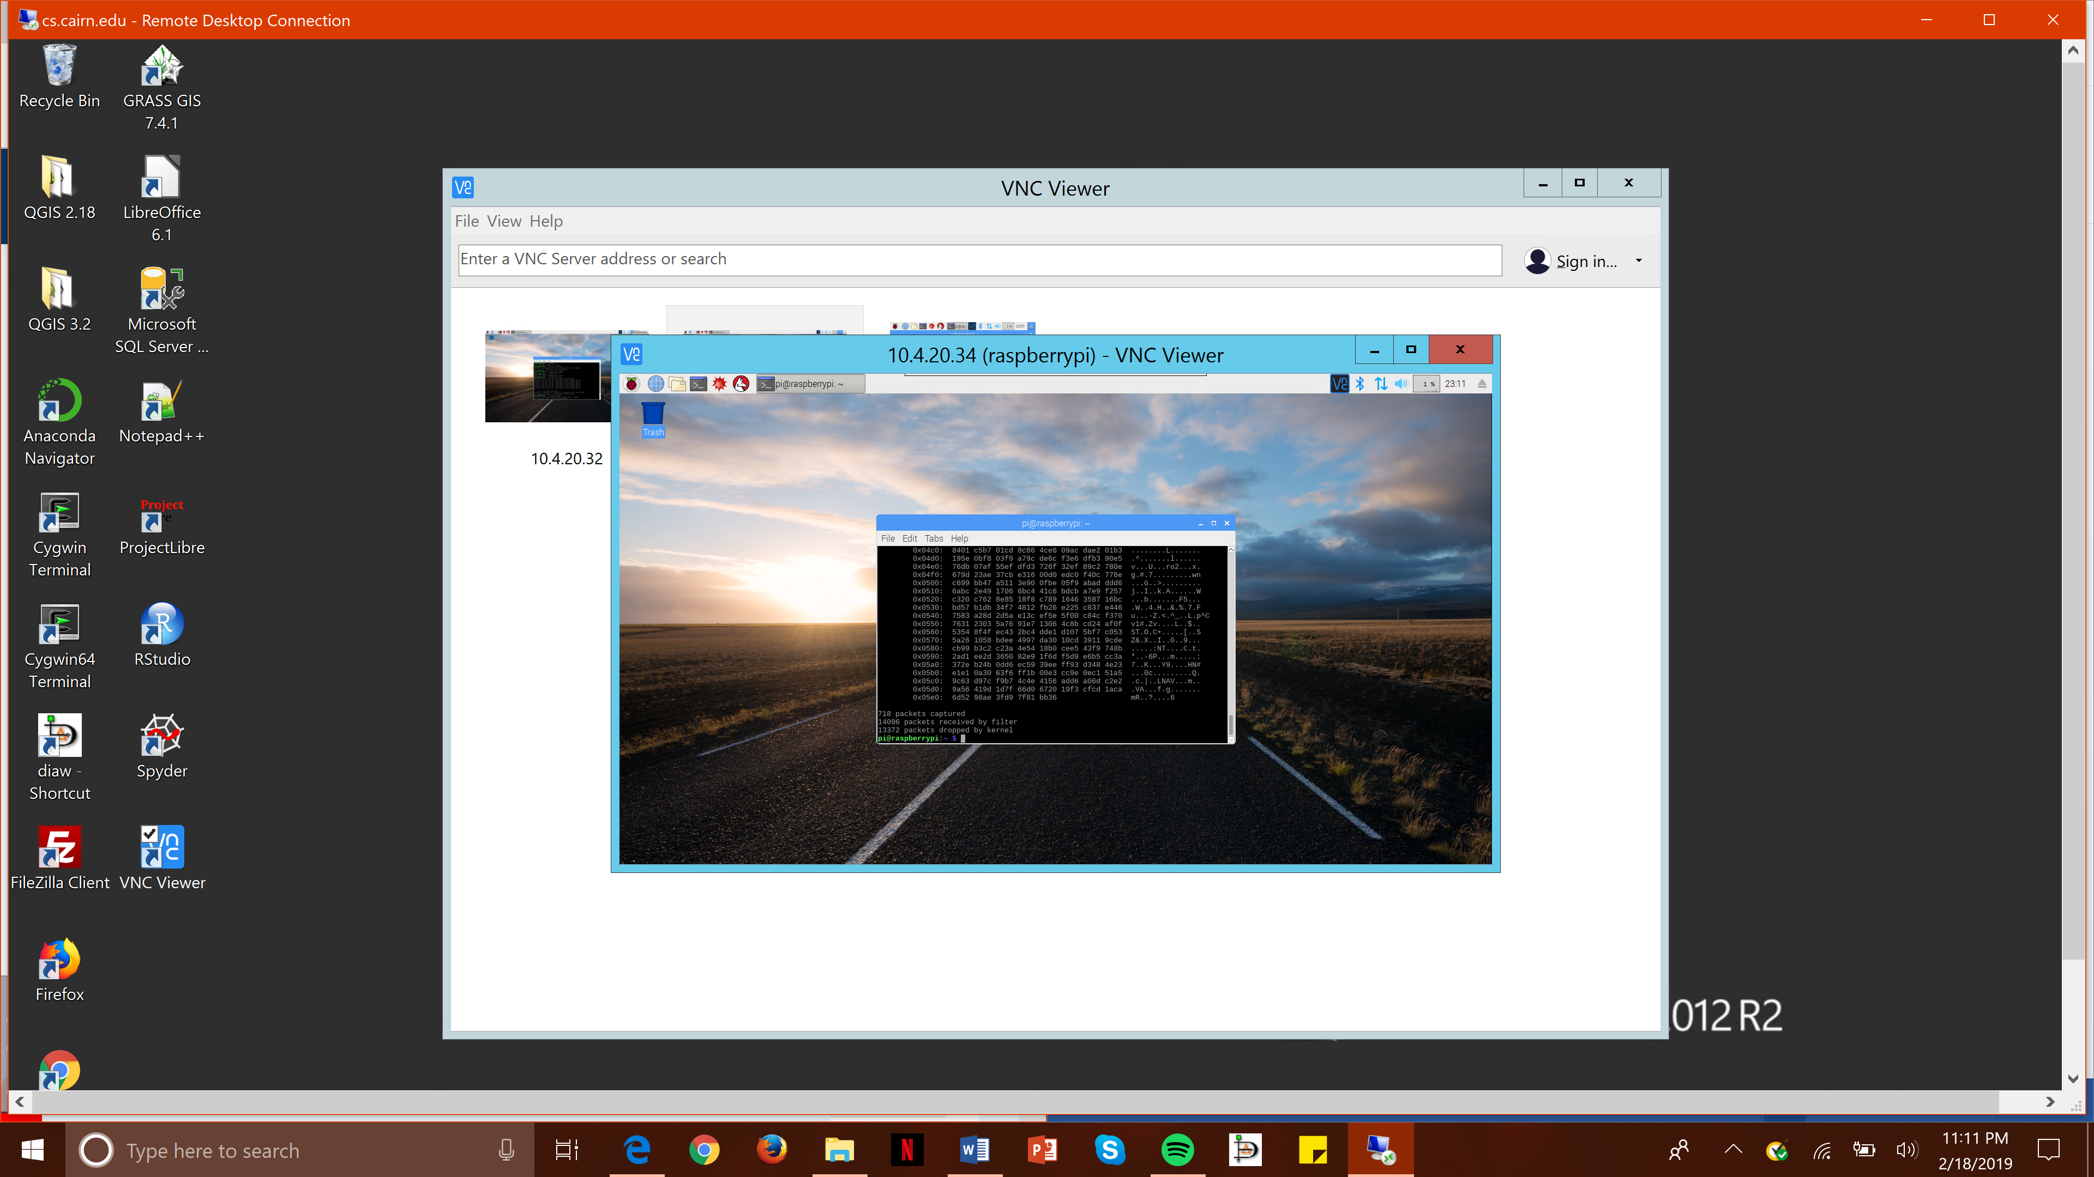

Open command prompt and then install the tcdump and check to see if the connection and packets are being sent through.

Configurations:

1. Make sure all devices are plugged in and connected to the internet.
2. Download VNC viewer based on the operating system being used. (Windows, IOS, Linux, etc)
3. Allow the different permissions being asked and after clicking yes there should be a white box with a search bar.
4. In the search bar put in the IP address of the computer you want to view in the VNC viewer so for example you would put “10.4.20.32”
5. Enter the username and password for the authentication and then click enter.
6. Open command prompt by going to the start and typing command prompt.
7. Then install tcdump or Wireshark by saying install tcdump or Wireshark process. (USING tcdump in this summary).